Meesho Product Dataset India
Meesho Product Listings, Prices & Reviews – Structured India Dataset
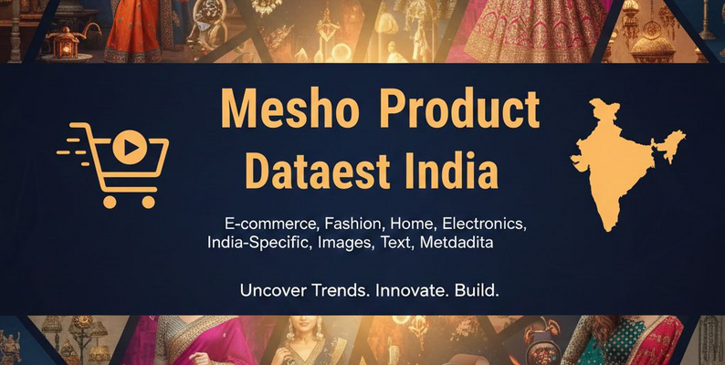

About Dataset
The Meesho E-commerce Product Dataset provides a comprehensive and structured view of one of India’s fastest-growing online marketplaces. Designed for businesses, analysts, researchers, and e-commerce intelligence teams, this dataset captures the full depth of Meesho’s dynamic catalog—ranging from fashion and lifestyle to home décor, beauty, electronics, and more.
Built using advanced data extraction pipelines, the dataset delivers high-quality, ready-to-use product information that helps organizations understand pricing strategies, consumer demand, competitive positioning, and emerging market trends across India’s Tier-2, Tier-3, and value-focused customer segments.
What This Dataset Includes
The Meesho Product Dataset covers all essential product-level attributes needed for robust analysis and decision-making.
- Product Details
Product title & description
Category & subcategory
Brand/vendor details
Style, material, and key attributes
- Pricing & Discount Insights
MRP, selling price, final price
Discount percentage
Promotional offers
Price fluctuation tracking (if updated periodically)
- Inventory & Availability
Stock status
Size & color variants
Restock patterns
Availability trends across multiple sellers
- Media & Visual Attributes
High-quality product images
Variant images
Thumbnail previews
- Ratings & Reviews
Average rating
Number of reviews
Buyer feedback snippets
Sentiment indicators (based on text analysis, if added)
- Seller & Marketplace Insights
Seller ID & name
Seller rating
Product popularity indicators
Delivery timelines & shipping details
Why This Dataset Is Valuable
Meesho is a major driver of India’s social commerce and budget-friendly online shopping ecosystem. Its product diversity, low-price offerings, and reseller-driven model make it an important platform for market intelligence.
This dataset helps in:
✔ Market Trend Analysis
Identify fast-moving categories, popular product types, and emerging consumer preferences.
✔ Competitive Benchmarking
Compare pricing, discount patterns, and catalog depth across marketplaces.
✔ Product Research & Development
Use real consumer feedback and attribute trends to refine product design and sourcing decisions.
✔ Pricing & Promotion Strategy
Analyze competitor pricing behavior in real time to optimize your own pricing models.
✔ E-commerce Intelligence & Automation
Feed ready-to-use data into BI tools, dashboards, AI models, and automation workflows.
Ideal For
E-commerce analytics companies
Retail and D2C brands
Market research agencies
Price comparison platforms
Inventory & demand forecasting teams
Academic researchers and data scientists

